## Multiple Choice

1. (calculator not allowed)
 $$\lim_{n→∞}\frac{4n^{2}}{n^{2}+10000n}\text{ is }$$

  1. 0
 $\frac{1}{2500}$

  2. 1
   3. 4
   4. nonexistent
2. (calculator not allowed) The $\lim_{h→0}\frac{tan3\left(x+h\right)-tan3x}{h}$ is
   1. 0
 $3\sec^{2}\left(3x\right)$

 $\sec^{2}\left(3x\right)$

 $3cot\left(3x\right)$

2. nonexistent
3. (calculator not allowed) $\lim_{x→0}\frac{7x-sinx}{x^{2}+sin\left(3x\right)}=$
   1. 6
   2. 2
   3. 1
   4. 0
4. (calculator not allowed) At $x=3$, the function given by $f\left(x\right)=\left\{\begin{matrix}x^{2}, & x<3 \\ 6x-9, & x≥3\end{matrix}\right.$ is
   1. undefined.
   2. continuous but not differentiable.
   3. differentiable but not continuous.
   4. neither continuous nor differentiable.
   5. both continuous and differentiable
5. (calculator allowed) 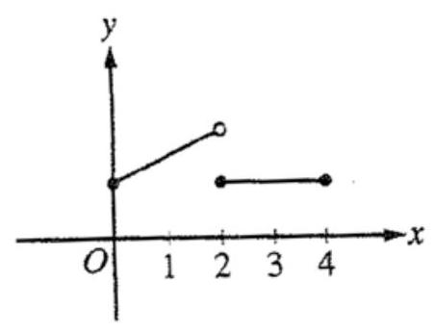. The figure above shows the graph of a function $f$ with domain $0≤x≤4$. Which of the following statements are true? I. $\lim_{x→2^{-}}f\left(x\right)$ exists II. $\lim_{x→2^{+}}f\left(x\right)$ exists III. $\lim_{x→2}f\left(x\right)$ exists
   1. I only
   2. II only
   3. I and II only
   4. I and III only
   5. I, II, and III
6. (calculator not allowed) If $f\left(x\right)=2x^{2}+1$, then $\lim_{x→0}\frac{f\left(x\right)-f\left(0\right)}{x^{2}}$ is
   1. 0
   2. 1
   3. 2
   4. 4
   5. nonexistent
7. (calculator not allowed) If $f^{'}\left(x\right)=cosx$ and $g^{'}\left(x\right)=1$ for all $x$, and if $f\left(0\right)=g\left(0\right)=0$, then $\lim_{x→0}\frac{f\left(x\right)}{g\left(x\right)}$ is
 $\frac{π}{2}$

  1. 1
   2. 0
   3. -1
   4. nonexistent
8. (calculator not allowed)

$$f\left(x\right)=\left\{\begin{matrix}ln\left(4x-7\right)\text{ if }x<2 \\ 4x-7\text{ if }x≥2\end{matrix}\right.$$

* Let $f$ be the function defined above. Which of the following statements about $f$ are true? I. $\lim_{x→2^{-}}f\left(x\right)=\lim_{x→2^{+}}f\left(x\right)$ II. $\lim_{x→2^{-}}f^{'}\left(x\right)=\lim_{x→2^{+}}f^{'}\left(x\right)$ III. $f$ is differentiable at $x=2$
  1. I only
  2. II only
  3. II and III only
  4. I, II, and III

1. (calculator not allowed) If $\lim_{x→a}f\left(x\right)=L$ where $L$ is a real number, which of the following must be true?
   1. $f^{'}\left(a\right)$ exists.
   2. $f\left(x\right)$ is continuous at $x=a$.
   3. $f\left(x\right)$ is defined at $x=a$.
 $f\left(a\right)=L$

  4. None of the above
2. (calculator not allowed) For $x≥0$, the horizontal line $y=2$ is an asymptote for the graph of the function $f$. Which of the following statements must be true?
 $f\left(0\right)=2$

 $f\left(x\right)≠2$ 1. for all $x≥0$
   2. $f\left(2\right)$ is undefined.
$\lim_{x→2}f\left(x\right)=∞$

$\lim_{x→∞}f\left(x\right)=2$

3. (calculator not allowed) If the graph of $y=\frac{ax+b}{x+c}$ has a horizontal asymptote at $y=2$ and a vertical asymptote at $x=-3$, then $a+c=$
   1. -5
   2. -1
   3. 0
   4. 1
   5. 5
4. (calculator not allowed) $\lim_{x→∞}\frac{\left(2x-1\right)\left(3-x\right)}{\left(x-1\right)\left(x+3\right)}$ is
   1. -3
   2. -2
   3. 2
   4. 3
   5. nonexistent
5. (calculator not allowed) $f\left(x\right)=\left\{\begin{matrix}\frac{x^{2}-4}{x-2}, & x≠2 \\ 1, & x=2\end{matrix}\right.$ Let $f$ be the function defined above. Which of the following statements about $f$ are true?   
   I. $f$ has a limit at $x=2$.

II. $f$ is continuous at $x=2$.

III. $f$ is differentiable at $x=2$.

(a) I only (a) II only (a) III only (a) I and II only (a) I, II, and III



$f\left(x\right)=\left\{\begin{matrix}x+2b\text{ if }x≤2 \\ ax^{2}\text{ if }x>2\end{matrix}\right.$

Let $f$ be the function given above. What are all values of $a$ and $b$ for which $f$ is differentiable at ?

* 1. and
  2. and $b=\frac{1}{2}$
  3. $a=\frac{1}{4}$ and $b$ is any real number
  4. $a=b+2$, where $b$ is any real number
  5. There are no such values of $a$ and $b$

1. (calculator not allowed) If the function $f$ is continuous for all real numbers and if $f\left(x\right)=\frac{x^{2}-4}{x+2}$ when $x≠-2$, then $f\left(-2\right)=$
   1. -4
   2. -2
   3. -1
   4. 0
   5. 2
2. (calculator not allowed) 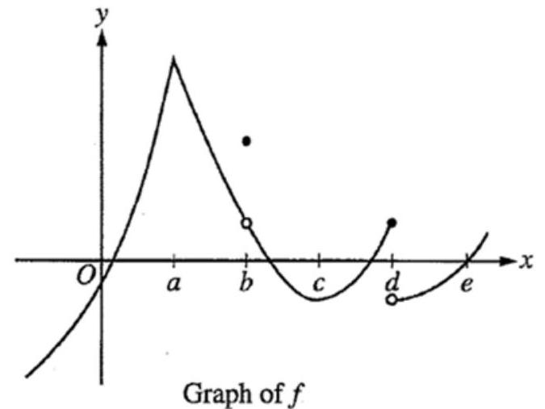 The graph of a function $f$ is shown above. At which value of $x$ is $f$ continuous, but not differentiable?
$a$

$b$

$c$

$d$

$e$

3. (calculator allowed) 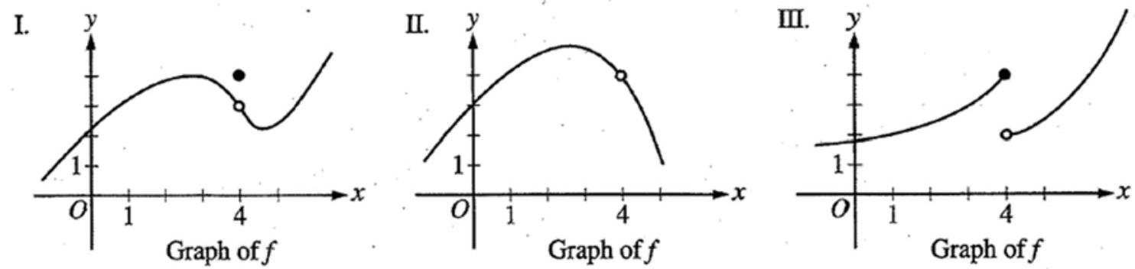 For which of the following does $\lim_{x→4}f\left(x\right)$ exist?
   1. I only
   2. II only
   3. III only
   4. I and II only
   5. I and III only
4. (calculator not allowed) $\lim_{x→e}\frac{lnx-1}{x-e}$ is
 $\frac{1}{e}$

  1. 1
 $e$

  2. Nonexistent  
       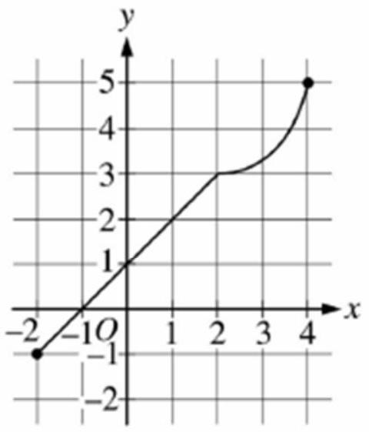 Graph of $f$ 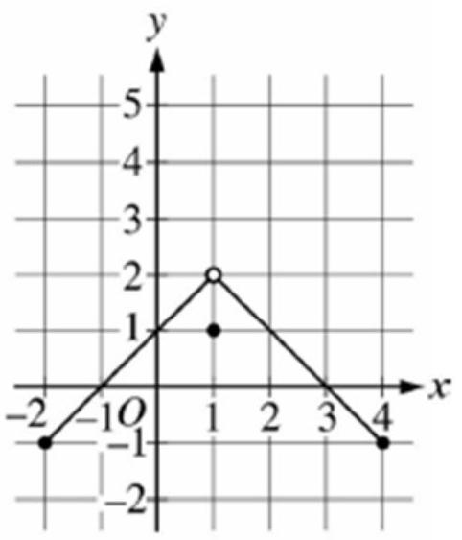 Graph of $g$
5. The graphs of the functions $f$ and $g$ are shown above. The value of $\lim_{x→1}f\left(g\left(x\right)\right)$ is
   1. 1
   2. 2
   3. 3
   4. nonexistent